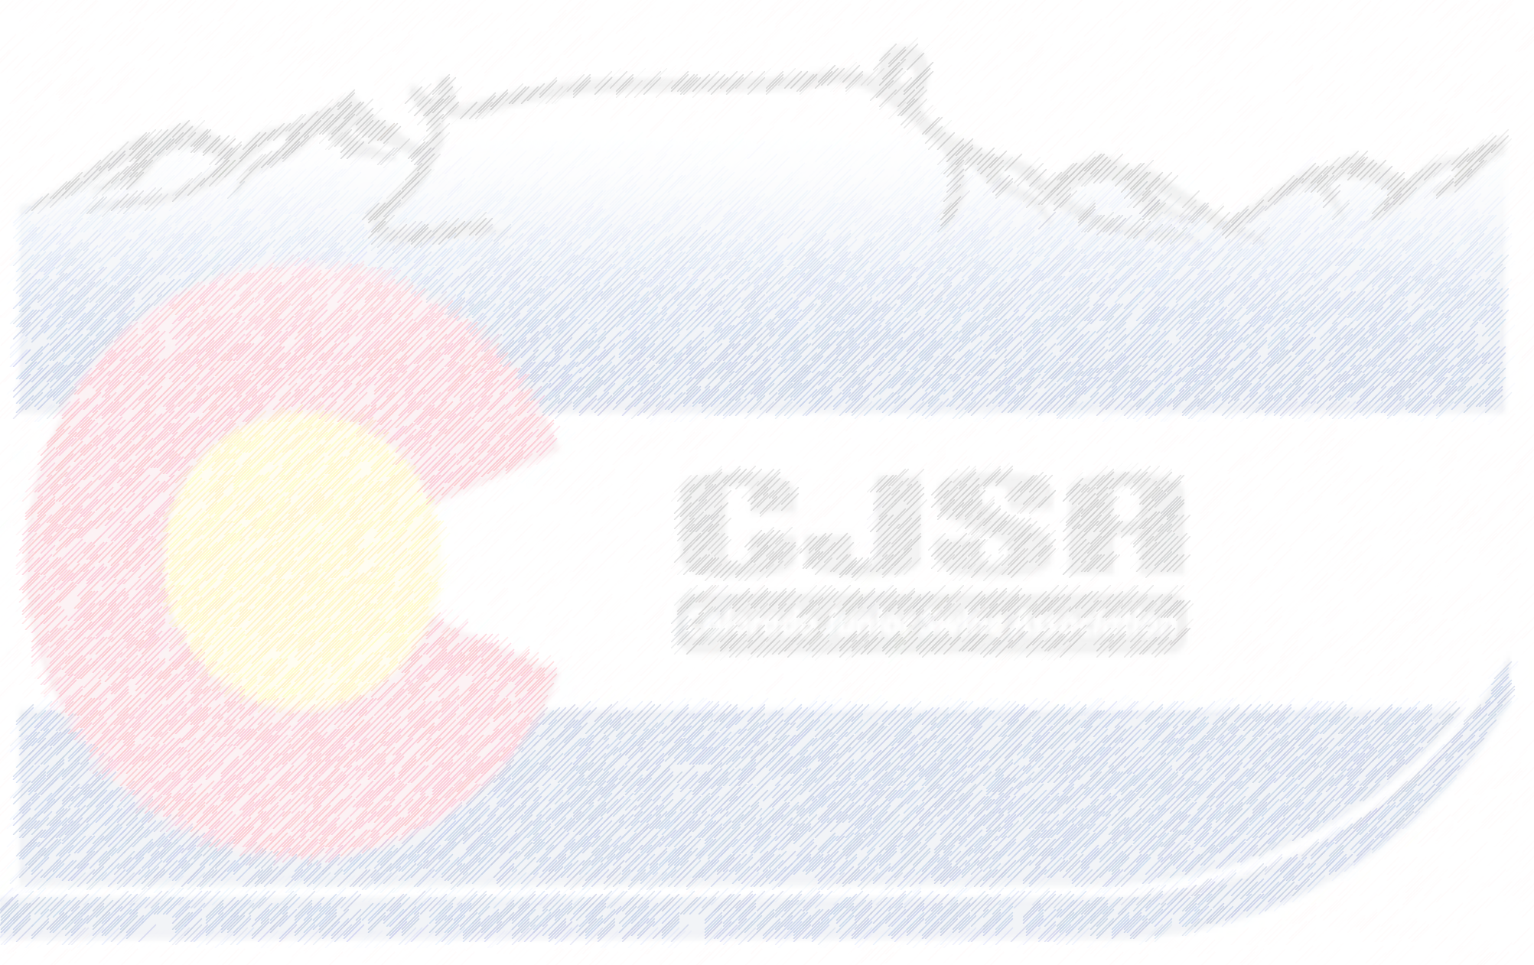
CJSA Updated Classification 2021
Berkshire
- Predominantly black in color
- Exhibiting Berkshire breed character (i.e. Erect Ears, white on face)
- 3 of 4 legs must be white (4 legs being white is ideal)
- Must have white on nose
- Can have white on face and ears (must not be solid black or white on face and ears must not be solid white.)
- NO evidence of formation of a belt or excessive white on body

Duroc
- Must be solid red in color
- Exhibiting Duroc Breed Character (i.e. Down Ears)
- No white or black hairs
- Black spots can’t be larger than a quarter

Hampshire
- Predominantly black in color with a white belt fully encircling the body over the shoulders encompassing the front legs
- Must exhibit Hampshire breed character (i.e. Erect ears)
- Sheath or navel must be black
- No white above the cap of the hock or white behind the navel or sheath
- Can have white on the nose but must not break the brim of the nose
- Excessive freckling in the belt may be cause for being classed out

Yorkshire
- Must be solid white in color
- Exhibiting Yorkshire Characteristics (i.e. Erect ears)
- No colored hairs
- Any indication of masking will be classed out
- Pigment over the size of a quarter will be classed out

Chester
- Must be solid white
- Exhibiting Chester White character (i.e. down ears)
- No colored hairs
- Any indication of masking will be classed out
- Pigment over the size of a quarter will be classed out

Landrace
- Must be solid white
- Exhibiting Landrace character (i.e. down ears)
- No colored hairs
- Any indication of masking will be classed out
- Pigment over the size of a quarter will be classed out

Spot
- Must be black and white in color
- Exhibiting Spotted character (i.e. down ears)
- No red hairs
- Any indication of a belt will be classed out
- Hogs with solid black faces will be classed out

Poland
- Predominantly black in color
- Exhibiting Poland China breed character (i.e. down ears, white on face)
- 3 of 4 legs must be white (4 legs being white is ideal)
- Must have white on nose
- Can have white on face and ears (must not be solid black or white on face and ears must not be solid white.)
- NO evidence of formation of a belt or excessive white on body

Dark Crossbred
- Hogs with black pigmentation or hair larger than a U.S. Quarter

Light Crossbred
- Hogs without black pigmentation or hair larger than a U.S. Quarter

